COURSE NAME: Theory of Computation COURSE CODE: CSA1304

COURSE OUTCOME COVERED

CO2: Deign Finite Automata DFA, NFA, ε-NFA and demonstrate their equivalence for recognizing regular languages. (BL:3)

Assessment Tool Weightage: 20%

QUESTIONS: 5 Total Marks:20
Duration : 1 Hour

Scenario Based

Code of Conduct:

I SRIVARSHA M - 192371010 (Name / Reg No) certify that this submission is my original work and that I have adhered to the guidelines specified for this assessment.
I understand that any violation of academic integrity rules will result in disciplinary action. Signature of the student:
SRIVARSHA M
- Given a DFA used for validating a specific PIN pattern bbbc, bca ,c, ca, caaaaaa minimize the DFA and explain how state reduction improves performance and efficiency in embedded systems

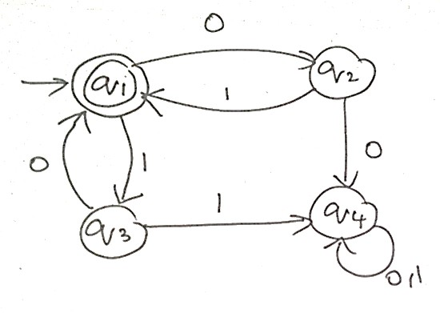
- Demonstrate how a given finite automaton can be converted into a regular expression
- Consider the following grammar S->aSc|T|U|e
T-> bTc|e U->aUb|e
A} What is the language defined by the grammar?
B)Give the derivation tree for the word aaabbc
C Grammar is Ambiguous if there exists two distinct derivations for a word. Is the above grammar ambiguous? Justify.

- I)Show that if L1 and L2 are regular then (L1+l2) also regular Ii)Is the language { a^p| p is prime} regular? Justify

Question 1 (5 Marks)

Given a DFA used for validating a specific PIN pattern bbbc, bca, c, ca, caaaaaa — minimize the DFA and explain how state reduction improves performance and efficiency in embedded systems.

Step 1: Identify the pattern in the language
The accepted strings bbbc, bca, c, ca and caaaaaa all share one structure: zero or more b's, followed by exactly one c, followed by zero or more a's. Writing this as a regular expression:
L = b* c a*
Verification against the given samples:

Sample string | b-count (n) | c | a-count (m) | Matches bⁿ c aᵐ ?
c | 0 | 1 | 0 | Yes
ca | 0 | 1 | 1 | Yes
bca | 1 | 1 | 1 | Yes
bbbc | 3 | 1 | 0 | Yes
caaaaaa | 0 | 1 | 6 | Yes

Step 2: Construct an (unminimized) DFA
A direct construction of a DFA for L = b*ca* naturally produces five states — two separate states that behave identically before the 'c' is read (A and B), two separate states that behave identically after the 'c' is read (C and D), and one trap state T for any string that violates the pattern:

State | Meaning | Accepting?
A (start) | No symbol read yet / only 'b's read so far | No

State | Meaning | Accepting?
B | At least one 'b' has just been read | No
C | The 'c' has just been read | Yes
D | The 'c' has been read, followed by 'a's | Yes
T | Trap / dead state — pattern already violated | No
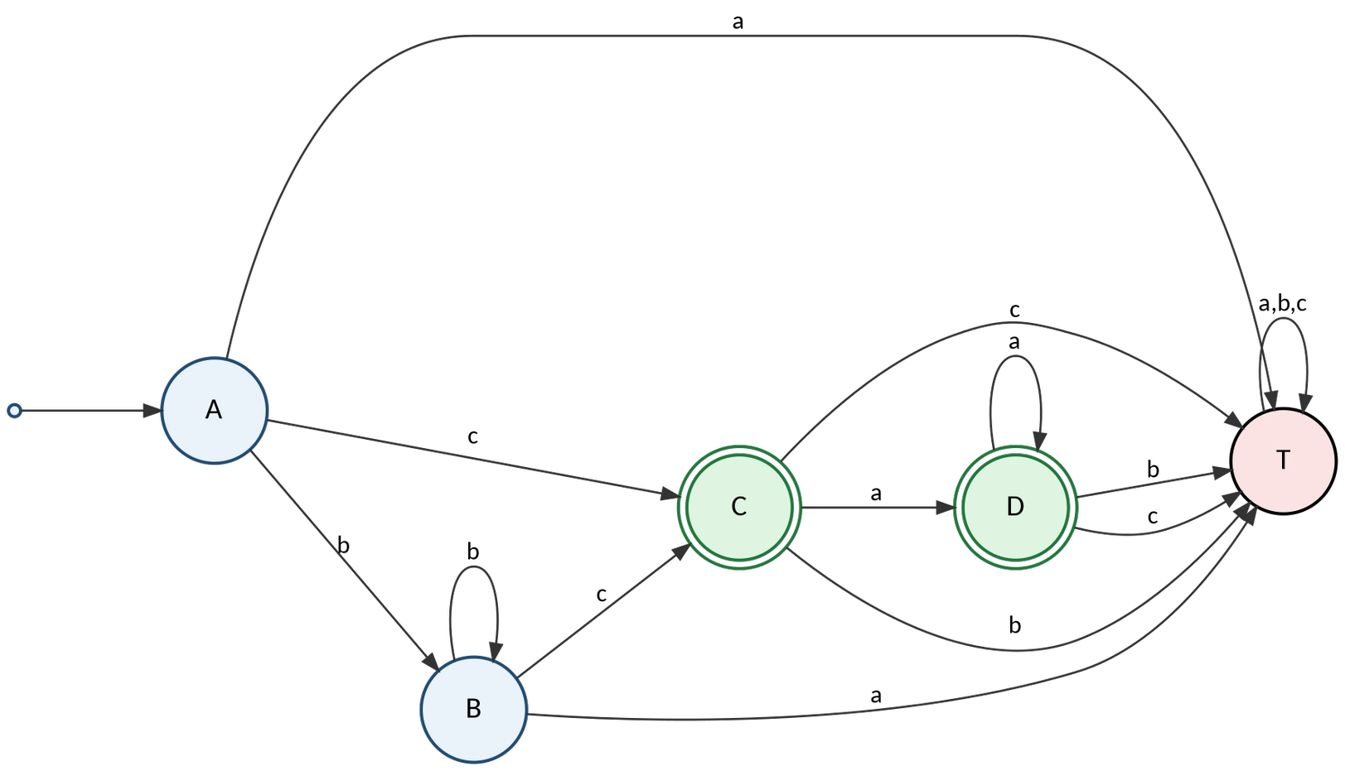
Fig. 1(a) — Initial DFA for L = b*ca* (5 states, before minimization)

Step 3: Minimize using the partition-refinement (table-filling) method
Group states first by accepting status, then repeatedly refine each group until no group can be split further.
Partition P₀ (by acceptance): {A, B, T} (non-accepting) {C, D} (accepting)
Refine {A, B, T} — compare the destination-group reached on each input symbol:

State | on a | on b | on c
A | T → (N) | B → (N) | C → (Y)
B | T → (N) | B → (N) | C → (Y)
T | T → (N) | T → (N) | T → (N)

A and B both give the signature (N, N, Y); T gives (N, N, N). Since T's signature differs, the group splits: {A, B} and {T}.
Refine {C, D} — compare destinations:

State | on a | on b | on c
C | D → {C,D} | T → {T} | T → {T}

State | on a | on b | on c
D | D → {C,D} | T → {T} | T → {T}

C and D have identical signatures, so they remain merged. Re-checking {A, B} against the new partition confirms it is also stable. The final (stable) partition is:
P* = { A, B } ∪ { C, 𝙳 } ∪ { T } → q0 = {A,B}, q1 = {C,𝙳}, qd = {T}

Step 4: Minimized DFA
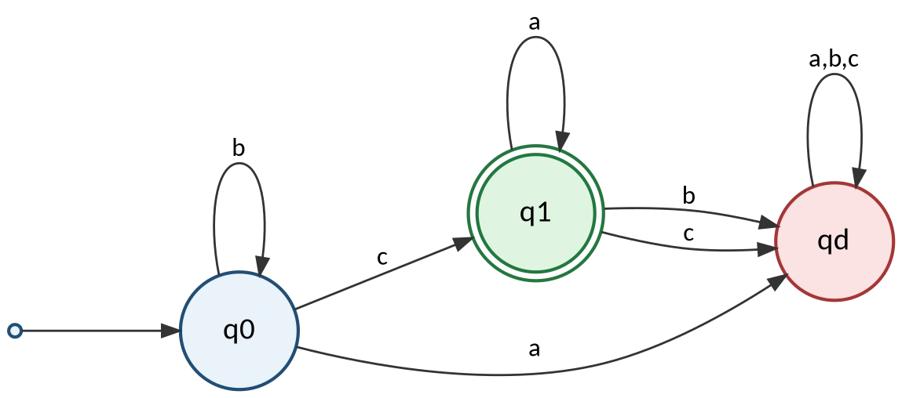
Fig. 1(b) — Minimized DFA M' = (Q', Σ, δ', q0, F') for L = b*ca*

Formal description of the minimized DFA:
Q' = {q0, q1, qd}, Σ = {a, b, c}, start state = q0, F' = {q1}
The DFA is reduced from 5 states to 3 states — a 40% reduction — with no change in the language accepted.

Step 5: How state reduction improves performance in embedded systems
- Smaller memory footprint: the transition table (state × symbol) shrinks from 5×3 to 3×3 entries, which matters directly on flash/ROM-constrained microcontrollers used in PIN-entry keypads and access-control modules.
- Faster state transitions: fewer states mean a smaller encoding (fewer bits per state register), so each transition lookup and comparison completes in fewer clock cycles — important for real-time PIN validation.
- Lower power consumption: fewer flip-flops/registers are toggled per transition in a hardware FSM implementation, reducing dynamic power draw — critical for battery-powered embedded devices such as door locks and card readers.
- Reduced silicon/logic area: in an FPGA or ASIC realization of the controller, fewer states translate to fewer logic gates and less routing, lowering unit cost.
- Simpler verification and testing: a minimal DFA has no redundant or equivalent states, so exhaustive testing and formal verification (model checking) of the embedded controller requires far fewer test cases.
- Easier maintenance: a minimized model is the unique canonical representation of the language, making future updates to the accepted PIN pattern easier to reason about correctly.

Question 2 (4 Marks)

Demonstrate how a given finite automaton can be converted into a regular expression.

Given automaton
The finite automaton in the question (redrawn below for clarity) has states v1 (start and only accepting state), v2, v3 and v4, over the input alphabet {0, 1}:
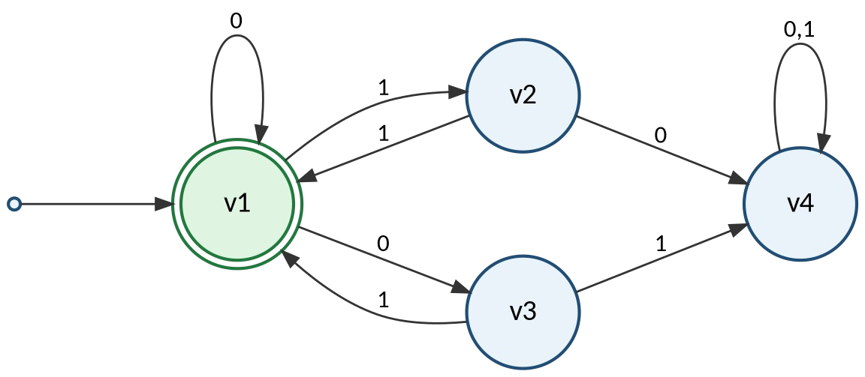
Fig. 2 — The given automaton

From state | On 0 | On 1
v1 (start, accepting) | v1, v3 | v2
v2 | v4 | v1
v3 | v4 | v1
v4 | v4 | v4

Method: state elimination using Arden's Theorem
For each state, write an equation for Rᵢ = the regular expression describing all input strings that take the automaton from the start state to state i. If R = Q + RP (P without ε), Arden's Theorem gives the unique solution R = QP•, where P• means P*.
Step 1 — write one equation per state (the start state also gets a free ε term):
Rᵥ1 = 𝖾 + Rᵥ1·0 + Rᵥ2·1 + Rᵥ3·1 Rᵥ2 = Rᵥ1·1
Rᵥ3 = Rᵥ1·0
Rᵥ4 = Rᵥ2·0 + Rᵥ3·1 + Rᵥ4·(0+1)
Step 2 — substitute Rᵥ2 and Rᵥ3 into the equation for Rᵥ1:
Rᵥ1 = 𝖾 + Rᵥ1·0 + (Rᵥ1·1)·1 + (Rᵥ1·0)·1 Rᵥ1 = 𝖾 + Rᵥ1·(0 + 11 + 01)
Step 3 — apply Arden's Theorem (Q = ε, P = 0 + 11 + 01):

Rᵥ1 = (0 + 11 + 01)•
Since v1 is the only accepting state, Rᵥ1 is precisely the language recognized by the automaton, so:
Regular expression: (0 + 01 + 11)*
Interpretation: the automaton accepts any string that can be broken into a sequence of blocks, where each block is 0, 01, or 11 — equivalently, every string over {0,1} in which no two consecutive 0's ever occur next to each other in a way that isn't separated by the start of a new '01'/'11'/'0' block (i.e. built from the given blocks only).

Question 3 (5 Marks)
- → aSc | T | U | ε
- → bTc | ε
- → aUb | ε

Language defined by the grammar
First solve the two helper non-terminals independently, since each is a simple self-embedding rule:
T → bTc | 𝖾 generates L(T) = { bⁿ cⁿ : n ≥ 0 }
U → aUb | 𝖾 generates L(U) = { aⁿ bⁿ : n ≥ 0 }
S wraps n copies of 'a _ c' around a base case chosen from {ε, T, U}. If S is expanded n times before hitting the base case, the result is aⁿ (base) cⁿ. Substituting each base case gives three families of strings, which together form L(S):
  - Base ε: S ⇒* aⁿ cⁿ for n ≥ 0
  - Base T: S ⇒* aⁿ bᵐ cᵐ⁺ⁿ for n, m ≥ 0 (T contributes bᵐcᵐ inside the a…c wrapper)
  - Base U: S ⇒* aᵐ⁺ⁿ bᵐ cⁿ for n, m ≥ 0 (U contributes aᵐbᵐ inside the a…c wrapper)
L(S) = { aⁿ cⁿ : n≥0 } ∪ { aⁿ bᵐ cᵐ⁺ⁿ : n,m≥0 } ∪ { aᵐ⁺ⁿ bᵐ cⁿ : n,m≥0 }
In words: L(S) is the set of all strings aʰ bᵏ cˢ (i,k,j ≥ 0) in which the number of c's equals the number of a's plus the number of b's that were generated on the U-side, OR the number of a's equals the number of b's plus the number of c's that were generated on the T-side — i.e. every string of the form a-block, b-block, c-block where the b-block is 'absorbed' either entirely into matching a's (U-branch) or entirely into matching c's (T-branch), or is empty (ε-branch, giving aⁿcⁿ). This is a classic context-free (non-regular) language.

Derivation tree for aaabbc
The word aaabbc has 3 a's, 2 b's and 1 c. Testing it against the U-branch family aᵐ⁺ⁿ bᵐ cⁿ with n = 1, m = 2 gives a3 bZ c¹ = aaabbc ✓. The leftmost derivation is:
S ⇒ aSc
⇒ aUc
⇒ a(aUb)c
⇒ aa(aUb)bc
⇒ aa(aεb)bc
⇒ aaabbc
(S → aSc, n = 1)
(S → U)
(U → aUb) (U → aUb)
(U → ε)

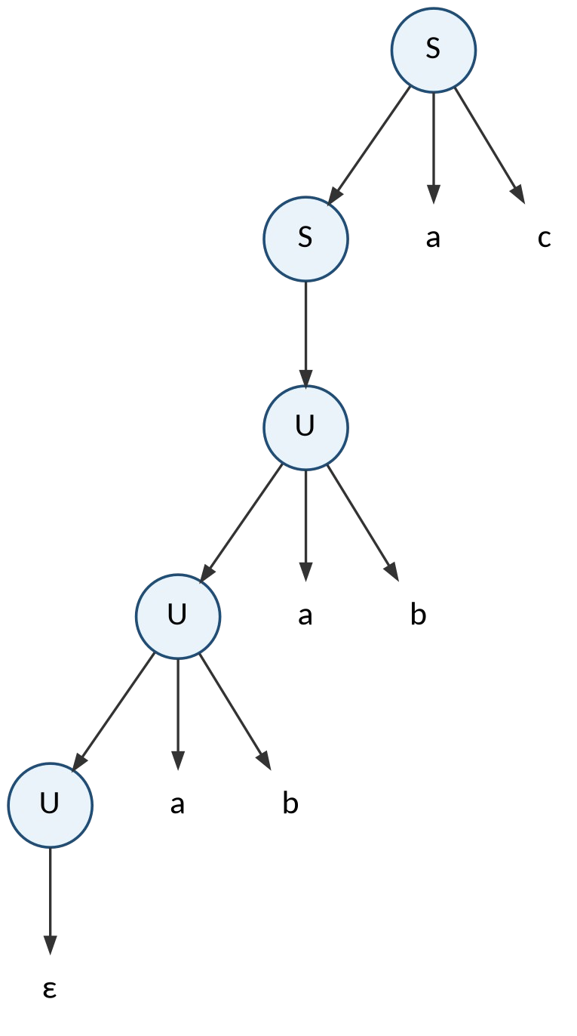
Fig. 3 — Derivation (parse) tree for the string aaabbc

Is the grammar ambiguous?
A grammar is ambiguous if some string has two distinct parse trees (or leftmost derivations). Look at the base cases of S: the productions S → ε, S → T and S → U are all reachable directly, and both T and U can themselves derive ε (via T → ε and U → ε). This means the empty string, and more generally every string aⁿ cⁿ, can be produced in three different ways:

Derivation route | Rule used at the base | Result for n copies of aSc
Route 1 | S → ε (direct base case) | aⁿ cⁿ
Route 2 | S → T, then T → ε | aⁿ cⁿ (T contributes b⁰c⁰ = ε)
Route 3 | S → U, then U → ε | aⁿ cⁿ (U contributes a⁰b⁰ = ε)

For example, the simple string "ac" (n = 1) has three distinct parse trees, corresponding to S ⇒ aSc ⇒ aεc, S ⇒ aSc
⇒ aTc ⇒ aεc and S ⇒ aSc ⇒ aUc ⇒ aεc — all yielding the same string "ac" via structurally different trees.
Conclusion: Yes, the grammar is ambiguous, because the three base-case productions (S → ε, S → T⇒ε, S → U⇒ε) overlap and generate the same strings aⁿcⁿ through distinct derivations.

Question 4 (6 Marks)

(I) If L1 and L2 are regular, then L1 ∪ L2 is also regular
Proof (closure construction using NFAs). Since L1 and L2 are regular, there exist finite automata (take them as NFAs, without loss of generality) N1 = (Q1, Σ, δ1, s1, F1) and N2 = (Q2, Σ, δ2, s2, F2) such that L(N1) = L1 and L(N2) = L2, with Q1 ∩ Q2 = ∅.
Construct a new NFA N = (Q, Σ, δ, s, F) as follows:
- Q = Q1 ∪ Q2 ∪ {s}, where s is a brand-new start state not in Q1 or Q2.
- δ(s, ε) = {s1, s2} (an ε-transition to both sub-automata's start states); δ agrees with δ1 on Q1 and with δ2 on Q2.
- F = F1 ∪ F2.
Any string w is accepted by N if and only if following the ε-move to s1 leads to acceptance in N1, or following the ε-move to s2 leads to acceptance in N2 — that is, iff w ∈ L1 or w ∈ L2. Hence L(N) = L1 ∪ L2. Since N is a finite automaton, L1 ∪ L2 is regular.
Equivalent regex argument: if r1 and r2 are regular expressions for L1 and L2, then (r1 + r2) is a regular expression by the very definition of regular expressions, and it denotes exactly L1 ∪ L2 — confirming closure directly.

(II) Is the language { aᵖ : p is prime } regular? — No
Claim: L = { aᵖ : p is prime } is not regular.
Proof (Pumping Lemma for regular languages). Suppose, for contradiction, that L is regular. Then L has a pumping length n ≥ 1 such that every string w ∈ L with |w| ≥ n can be split as w = xyz with |xy| ≤ n, |y| ≥ 1, and xyⁱz
∈ L for every i ≥ 0.
Since there are infinitely many primes, choose a prime p with p ≥ n, and let w = aᵖ (so w ∈ L and |w| = p ≥ n). By the pumping lemma, w = xyz with |y| = k for some 1 ≤ k ≤ n, and:
| x yⁱ z | = p + (i − 1)k for every i ≥ 0, and this string must lie in L.
Choose i = p + 1. Then:
| x yᵖ⁺¹ z | = p + p·k = p(1 + k)
Since k ≥ 1, we have (1 + k) ≥ 2, and p ≥ 2 (p is prime); therefore p(1 + k) is a product of two integers each ≥ 2, i.e. a composite number — it cannot be prime. But the pumping lemma requires x yᵖ⁺¹ z ∈ L, meaning its length must be prime. This is a contradiction.
Conclusion: no such pumping length can exist, so L = { aᵖ : p is prime } is not regular.

RUBRICS FOR CALCULATION

Criteria | Weightage | Level 4 –  Exemplary (5 Marks) | Level 3 –  Proficient (4 Marks) | Level 2 –  Developing (2–3 Marks) | Level 1 –  Beginning (0–1 Mark)
Conceptual Understandin g | 30 | Demonstrates clear and complete understanding  of the concept | Good understandin g with minor gaps | Basic understanding with some misconceptions | Poor or incorrect understandin g
Accuracy of Answer | 25 | Completely correct answer  with no errors | Mostly correct with  minor errors | Partially correct with noticeable  errors | Incorrect or irrelevant  answer
Application of Knowledge | 20 | Correctly applies concepts to solve the  question/proble m | Applies concepts with minor mistakes | Limited or partially correct application | No or incorrect application
Completeness of Response | 15 | Covers all required parts of the question | Covers most parts with  minor omissions | Covers only some parts | Incomplete or missing response
Clarity & Presentation | 10 | Clear, concise, and well-organized  answer | Understandab le with minor issues | Somewhat unclear or poorly  structured | Difficult to understand

